

KGiSL INSTITUTE OF TECHNOLOGY

**Project_Title : COVID-19 CASES**

**Mentor :** Indu Poornima R

**Team Members :**

KARTHIKEYAN B

TINU VARSHAN A S

LOGESH S

MOHAMED YASEEN M

**Project Description :** COVID-19 CASES

**Objective :**

This objective sets a broad overview of what you intend to achieve with your data analysis, which can then be broken down into specific tasks and analyses as you work on the project.

It seems like you're looking for a list of objectives related to COVID-19 cases data. These objectives can vary depending on the context and the specific goals of the analysis, but here are some common objectives for COVID-19 data analysis:

1. Monitor and Track Trends: Keep track of the number of COVID-19 cases over time to understand how the pandemic is evolving.

2. Identify Hotspots: Detect areas with high infection rates to allocate resources and implement targeted interventions.

3. Forecasting: Use historical data to make predictions about future COVID-19 cases, helping with resource planning and policy decisions.

4. Demographic Analysis: Analyze data to understand how different age groups, genders, and ethnicities are affected by the virus.

5. Healthcare System Capacity Planning: Ensure that healthcare facilities are prepared for surges in cases by analyzing hospitalization and ICU utilization data.

6. Vaccination Coverage: Monitor the progress of vaccination campaigns and identify areas where coverage is low.

7. Epidemiological Modeling: Build and validate epidemiological models to understand disease spread and inform public health measures.

8. Testing and Contact Tracing Efficiency: Evaluate the effectiveness of testing and contact tracing programs in controlling the spread of the virus.

9. Vaccine Efficacy Analysis: Assess the real-world effectiveness of vaccines in reducing the severity of illness and preventing transmission.

10. Public Health Interventions: Evaluate the impact of various interventions (lockdowns, mask mandates, social distancing measures) on COVID-19 transmission.

11. Mutation Analysis: Monitor the prevalence of different variants of the virus and assess their potential impact on transmissibility and vaccine efficacy.

12. Global Comparisons: Compare COVID-19 data across different regions and countries to identify lessons learned and best practices.

13. Public Communication: Develop data-driven messaging and public health campaigns to promote safety measures and vaccination.

14. Data Quality Assurance: Ensure the accuracy and consistency of COVID-19 data reporting to make informed decisions.

15. Long-Term Effects Analysis: Investigate the long-term health impacts of COVID-19 on individuals who have recovered from the virus.

16. Economic Impact Assessment: Analyze the economic consequences of the pandemic, including unemployment rates, business closures, and economic recovery.

17. Vulnerable Populations: Identify and support vulnerable populations, such as the elderly, individuals with underlying health conditions, and low-income communities.

18. Research and Innovation: Encourage and support research to develop new treatments, drugs, and diagnostics for COVID-19.

19. Public Policy Guidance: Provide data and insights to inform government policies and public health guidelines.

20. Community Engagement: Engage with communities to build trust and encourage compliance with public health measures.

These objectives can guide the collection, analysis, and interpretation of COVID-19 cases data to better understand the pandemic and make informed decisions to mitigate its impact.

**#Step_1 :**

Mounting the colab with the google drive for attaching the dataset to the program.



**#Step_2 :**

Loading the raw dataset from the drive by mounting it to the colab.

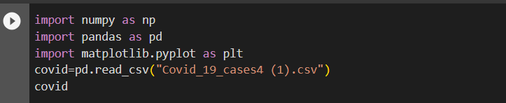

**#Output :**

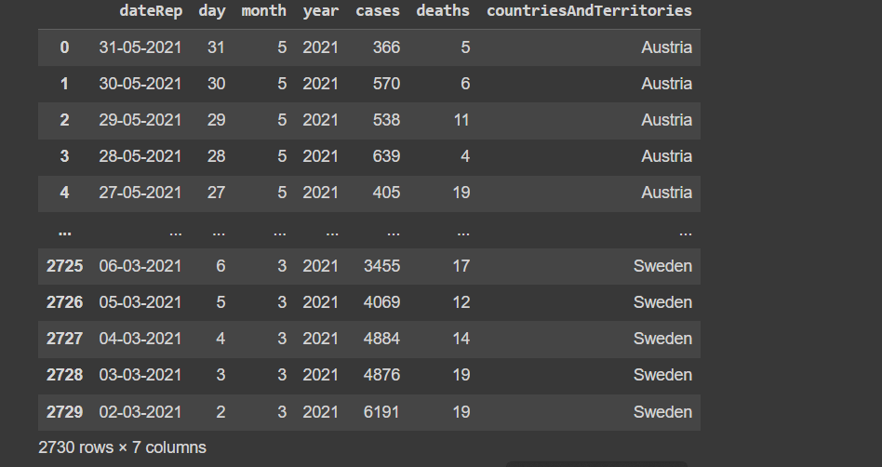

**#Step_3 :**

The step involves the processing of the raw dataset.

**#Processing :**

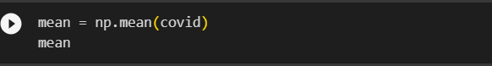

**#Output :**

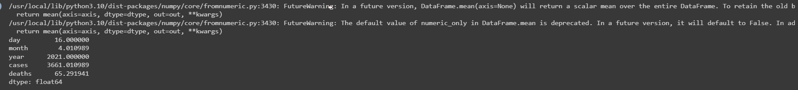

**#Step_4 :**

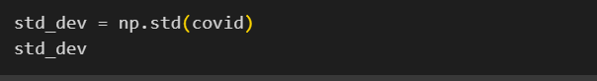

**#Output :**

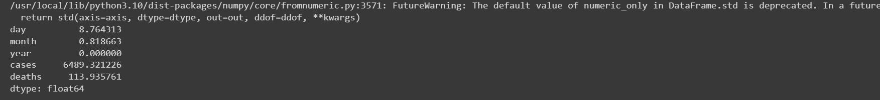

**#Step_5 :**

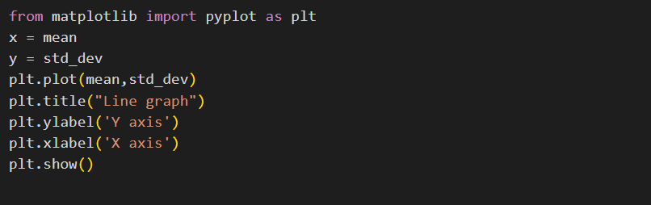

**#Output :**

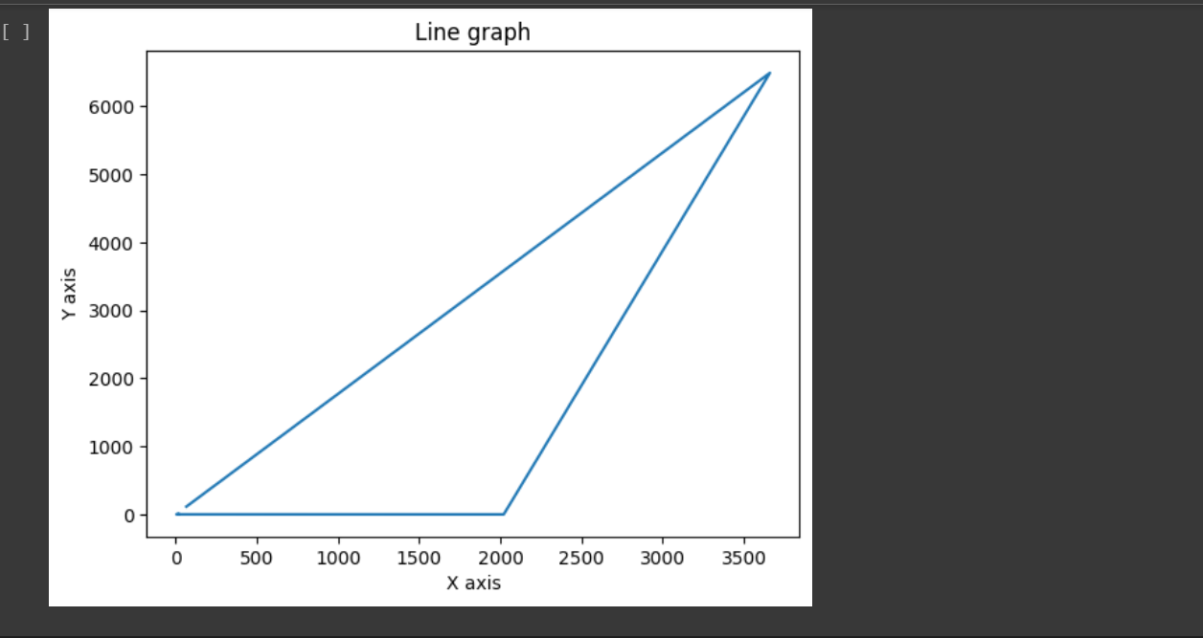

**#Step_6 :**

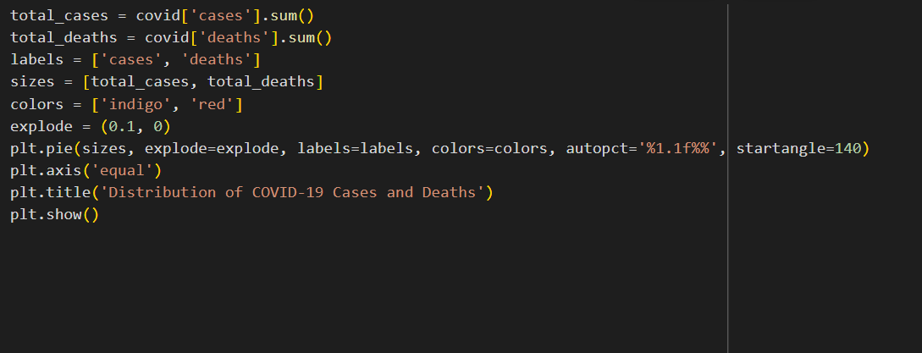

**#Output :**

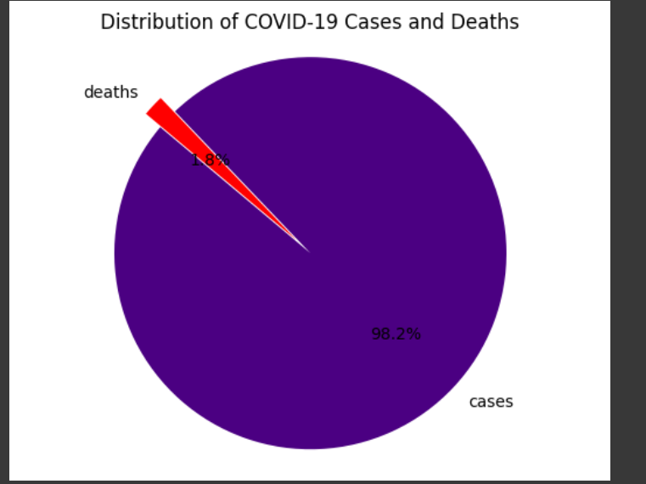

**#Step_7 :**

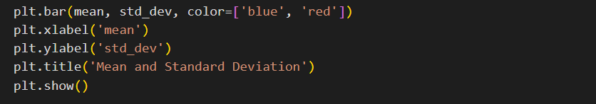

**#Output :**

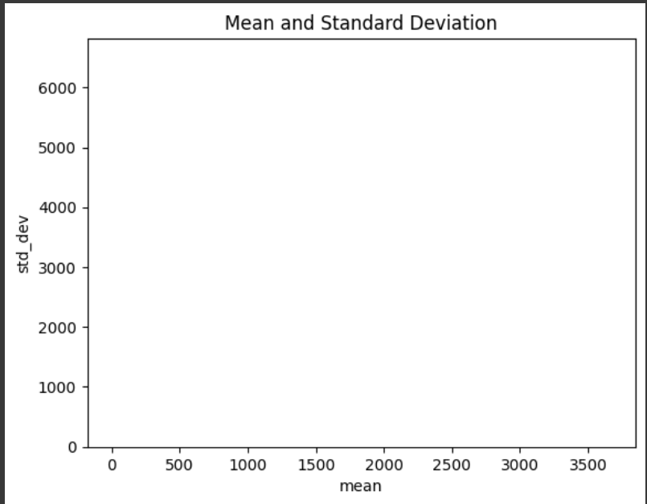

**#Step_8 :**



**#Output :**



**#Step_9 :**



**#Output :**

